**Experiment 9**

**ECE 367 Spring 2016**

**Sri Vadrevu**

**UIN: 650396090**

**April 27, 2016**

**TA: Owen Shi**

**Electric Circuit Diagram**

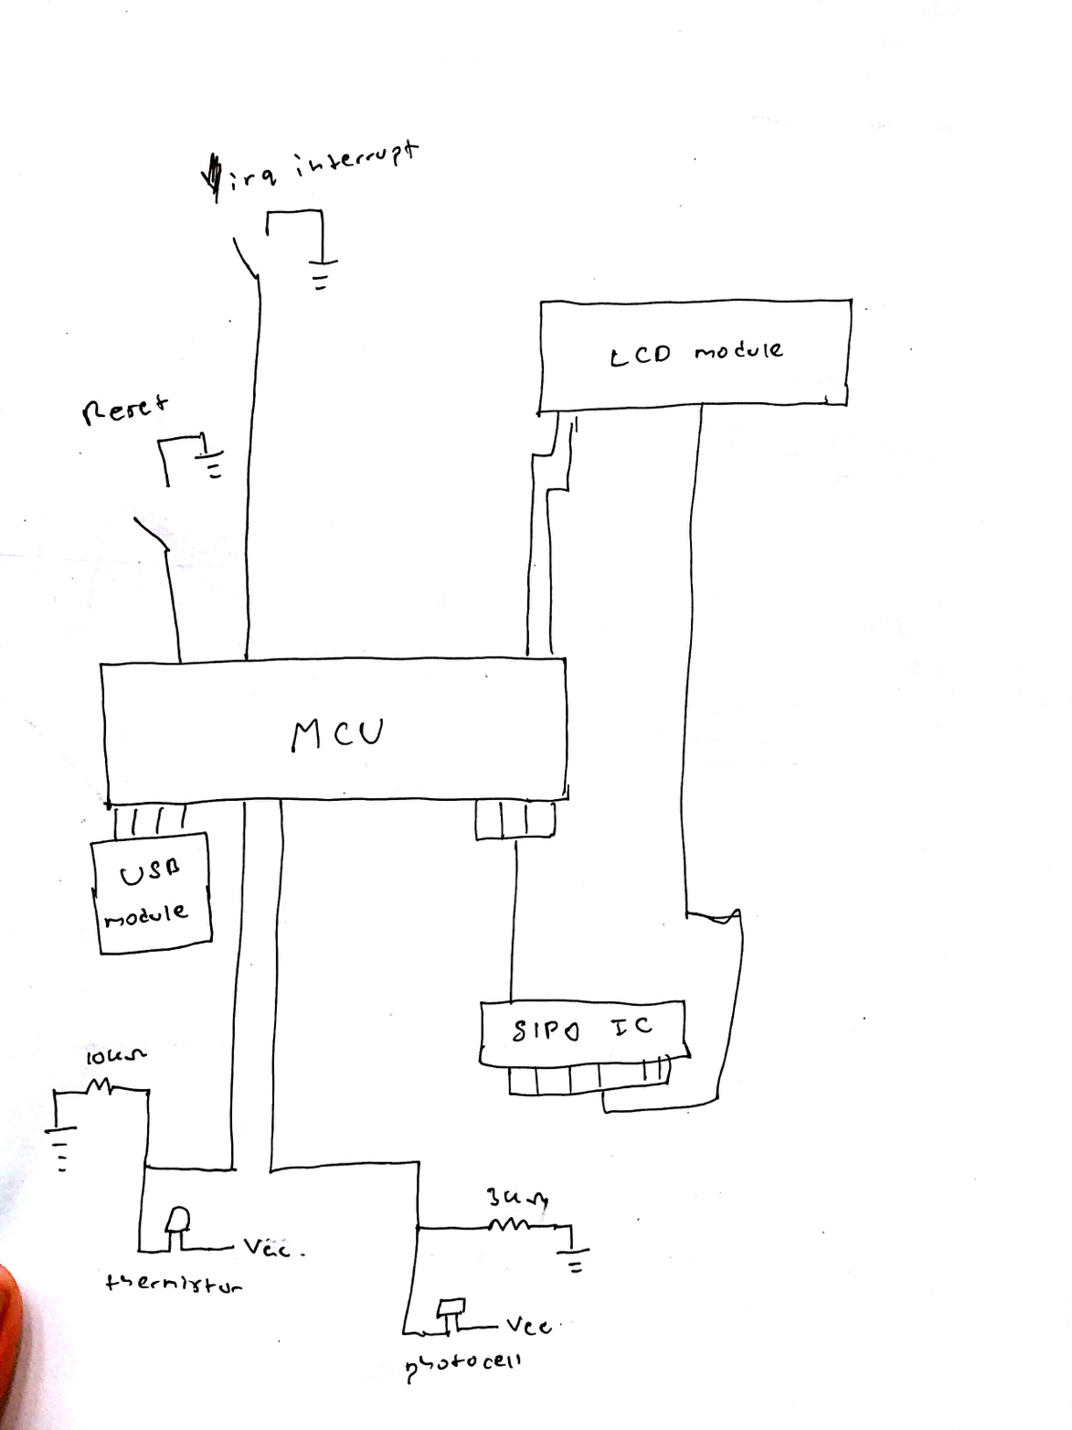

**Debug Log**

Debugging for this lab was fairly minimal in terms of working the ATD module, most debugging stemmed from providing proper readable output through the LCD module for the user.

***Problem:***  After setting up the ATD resistors and the hardware, I tried testing to see whether I am properly conducting the ADC conversions. The thermistor worked out fairly well, but I could not get the photocell to work. Was consistently receiving a conversion value of 1023 when performing continuous 10-bit conversions.

***Solution:*** I actually realized the hardware I had set up for the photocell was wrong. The lab prompt asked for a voltage divider circuit for the thermistor and series circuit for the photocell. In fact, a voltage divider circuit is required for both of transducers (thermistor and photocell). After doing that, I started receiving actual proper values in the range of ~200 to ~500.

***Problem:*** I had trouble initially reading the raw data from the thermistor and the photocell. Initially I made if-else statements that would allow me to see where from 0 to 1023 is the range. However, this proved to be a tedious process, and required a lot of trial-and-errors.

***Solution:*** Since ADC conversion was stored in ATDR1 and ATDR0 as integers in the range from 0 to 1023. I was able to perform integer math in C to send that exact value to the LCD module. So if I received an 823 for the thermistor, I would see the 823 in the LCD display. I could not send the information directly, since each number that appears in the LCD module has a specific command for it. I had a look up table and had to correlate the commands with the actual number. Here’s an example of how I did it.

823🡪 temp

823/10 🡪 82

82/10 🡪 8 🡪 hundreds place

82%10 🡪 2 🡪 tens place

temp 🡪 823%10 🡪 ones place

By getting each individual place value I could access the look-up-table. For example LUT[8] would give me the command for number 8 on the LCD display.

**Conclusion**

This lab was perhaps the most though-provoking and interesting lab I have ever done for any class. Very interesting and very rewarding. The lab was straightforward and the ATD module was quite simple to use. The lecture slides and book helped out greatly as they provided a lot of examples. Before the presentable I had made were the light wave and the stopwatch. But now, we were able to essentially communicate with nature (temperature and light) and display that information to something usable by the user. This lab truly made use of everything we have learned in this class so far. Everything from creating pseudocode, visualizing the bigger picture, knowing where to look for questions, using the SPI, using the LCD module, everything. Overall, a very rewarding lab that gave me a good insight into the uses of embedded systems.